**PHASE 4: DEVELOPMENT_2**

Building and evaluating a model for COVID-19 vaccine analysis involves using data to predict outcomes or make informed decisions about vaccine efficacy, safety, distribution, and other related factors. Here are the steps to perform model building and evaluation in COVID-19 vaccine analysis:

1. **Define the Problem:**
   * Clearly state the research question or problem you want to address. For instance, you might want to predict vaccine effectiveness, identify factors affecting vaccination rates, or analyze adverse events associated with a specific vaccine.
2. **Data Collection:**
   * Gather relevant data from reliable sources. This may include clinical trial data, epidemiological data, healthcare records, or surveys. Ensure the data is clean, structured, and well-documented.
3. **Data Preprocessing:**
   * Clean and preprocess the data. This involves handling missing values, data transformation, and feature engineering. Ensure that the data is ready for analysis.
4. **Feature Selection/Extraction:**
   * Identify and select relevant features (variables) for your analysis. This step may involve feature engineering, dimensionality reduction, or other techniques to improve model performance.
5. **Model Selection:**
   * Choose appropriate machine learning or statistical models based on the nature of your problem. Common choices include regression models, classification models, time-series models, or deep learning models.
6. **Split Data:**
   * Divide your dataset into training, validation, and test sets. The training set is used to train the model, the validation set helps in hyperparameter tuning, and the test set is for final model evaluation.
7. **Model Training:**
   * Train the selected model on the training data using appropriate algorithms and techniques. Fine-tune hyperparameters as needed to optimize model performance.
8. **Model Evaluation:**
   * Evaluate the model's performance using appropriate metrics, such as accuracy, precision, recall, F1-score, or regression evaluation metrics (e.g., R-squared, RMSE). Evaluate both training and validation sets to check for overfitting.
9. **Hyperparameter Tuning:**
   * If needed, adjust hyperparameters to improve model performance. You can use techniques like grid search, random search, or Bayesian optimization.
10. **Validation and Cross-Validation:**
    * Implement cross-validation techniques to ensure your model generalizes well. This

|  |
| --- |
| import numpy as np  import pandas as pd  import matplotlib.pyplot as plt    data = pd.read_csv('case_time_series.csv')    Y = data.iloc[61:,1].values  R = data.iloc[61:,3].values  D = data.iloc[61:,5].values  X = data.iloc[61:,0]    plt.figure(figsize=(25,8))    ax = plt.axes()  ax.grid(linewidth=0.4, color='#8f8f8f')    ax.set_facecolor("black")  ax.set_xlabel('\nDate',size=25,color='#4bb4f2')  ax.set_ylabel('Number of Confirmed Cases\n',                size=25,color='#4bb4f2')    ax.plot(X,Y,          color='#1F77B4',          marker='o',          linewidth=4,          markersize=15,          markeredgecolor='#035E9B') |

**Output:**

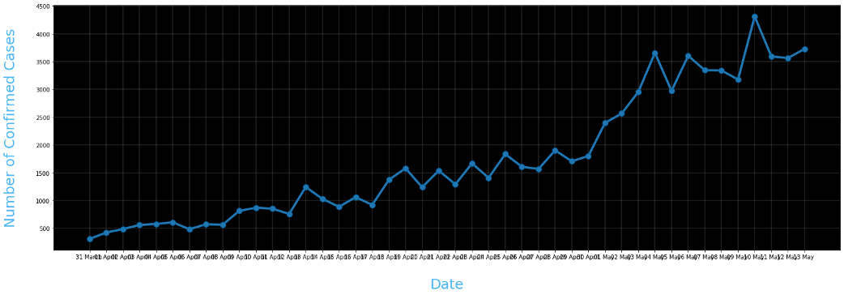

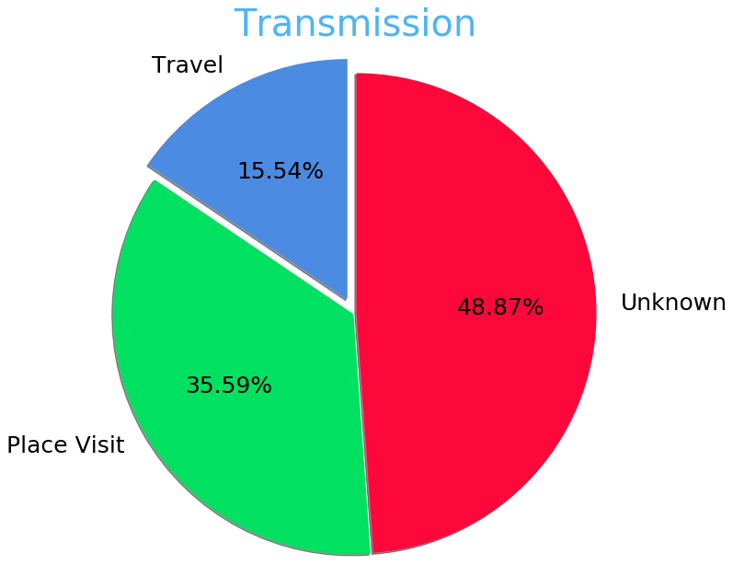

data = pd.read_csv('district.csv')

data.head()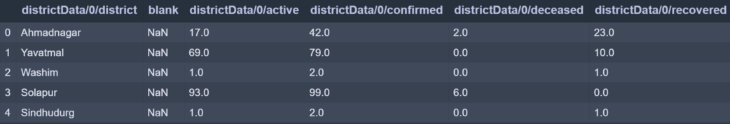

plt.bar(x,co,label='re')

plt.bar(x,re,label='re',color='green')

plt.bar(x,de,label='re',color='red')

plt.legend(['Confirmed','Recovered','Deceased'],

           fontsize=20)

**Output:**

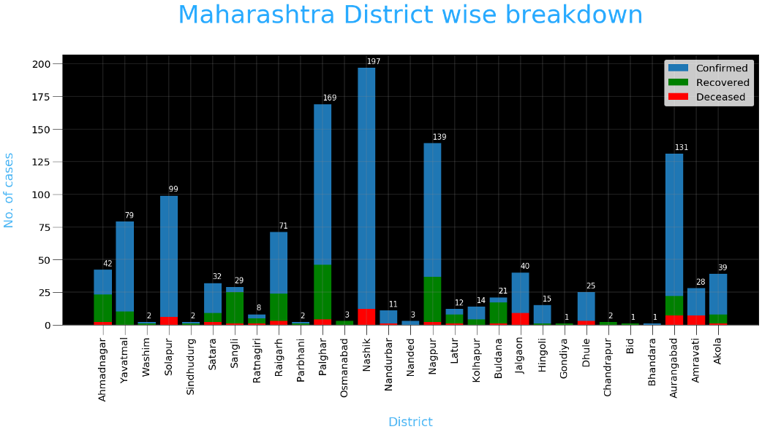

**Conclusion:**The successful development of the COVID-19 vaccine concerns almost all countries and people in the world. We must do an excellent job of researching the immunogenicity and immune reactivity of the vaccines. We hope this review can help colleagues at home and abroad.